10 Ways to Exercise Hands and Fingers
Medically Reviewed by Carol DerSarkissian, MD on October 01, 2022

Make a Fist
1/12
Hand and finger exercises can help strengthen your hands and fingers, increase your range of motion, and give you pain relief. Stretch only until you feel tightness. You shouldn't feel pain. Start with this simple stretch:
- Make a gentle fist, wrapping your thumb across your fingers.
- Hold for 30 to 60 seconds. Release and spread your fingers wide.
- Repeat with both hands at least four times.
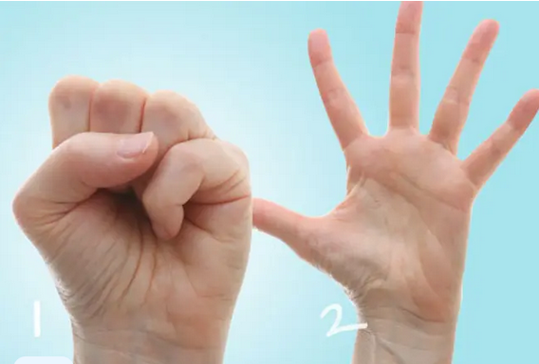

Finger Stretch
2/12
Try this stretch to help with pain relief and to improve the range of motion in your hands:
- Place your hand palm-down on a table or other flat surface.
- Gently straighten your fingers as flat as you can against the surface without forcing your joints.
- Hold for 30 to 60 seconds and then release.
- Repeat at least four times with each hand.
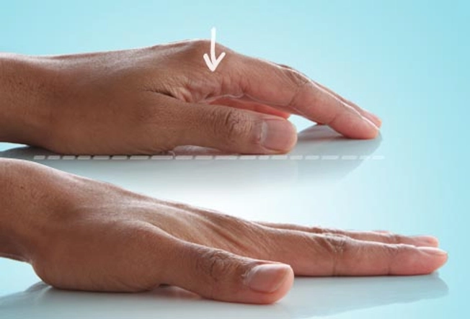

Claw Stretch
3/12
This stretch helps improve the range of motion in your fingers.
- Hold your hand out in front of you, palm facing you.
- Bend your fingertips down to touch the base of each finger joint. Your hand should look a little like a claw.
- Hold for 30 to 60 seconds and release. Repeat at least four times on each hand.
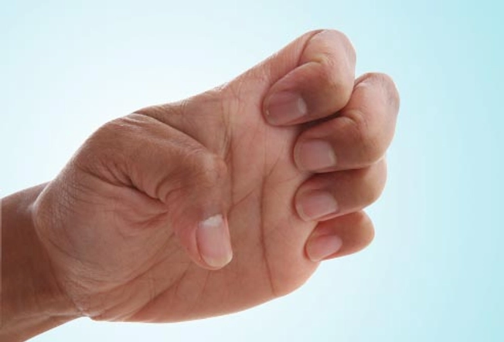

Grip Strengthener
4/12
This exercise can make it easier to open door knobs and hold things without dropping them.
- Hold a soft ball in your palm and squeeze it as hard as you can.
- Hold for a few seconds and release.
- Repeat 10 to 15 times on each hand. Do this exercise two to three times a week, but rest your hands for 48 hours in between sessions. Don't do this exercise if your thumb joint is damaged.
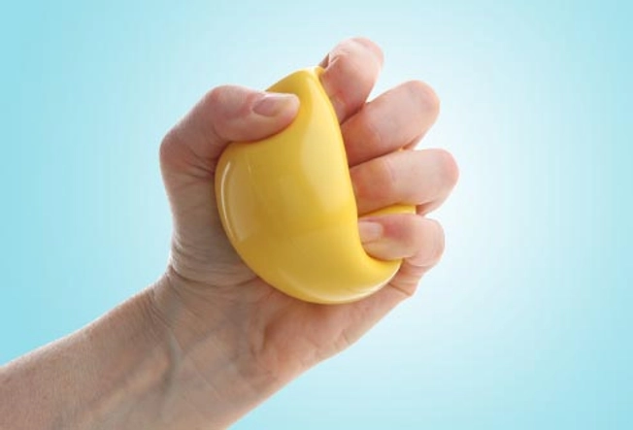

Pinch Strengthener
5/12
This exercise helps strengthen the muscles of your fingers and thumb. It can help you turn keys, open food packages, and use the gas pump more easily.
- Pinch a soft foam ball or some putty between the tips of your fingers and your thumb.
- Hold for 30 to 60 seconds.
- Repeat 10 to 15 times on both hands. Do this exercise two to three times a week, but rest your hands for 48 hours in between sessions. Don't do this exercise if your thumb joint is damaged.
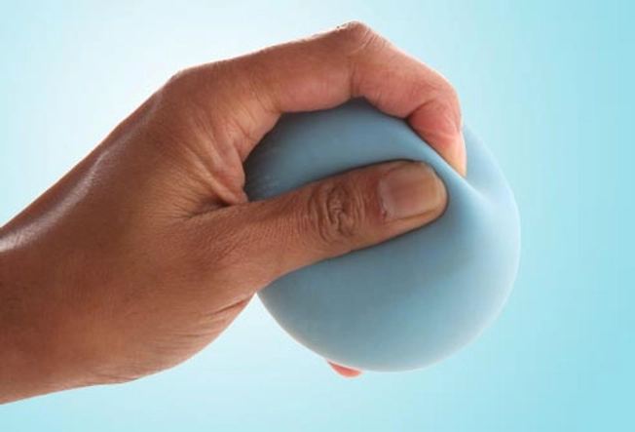

Finger Lift
6/12
Use this exercise to help increase the range of motion and flexibility in your fingers.
- Place your hand flat, palm down, on a table or other surface.
- Gently lift one finger at a time off of the table and then lower it.
- You can also lift all your fingers and thumb at once, and then lower.
- Repeat eight to 12 times on each hand.
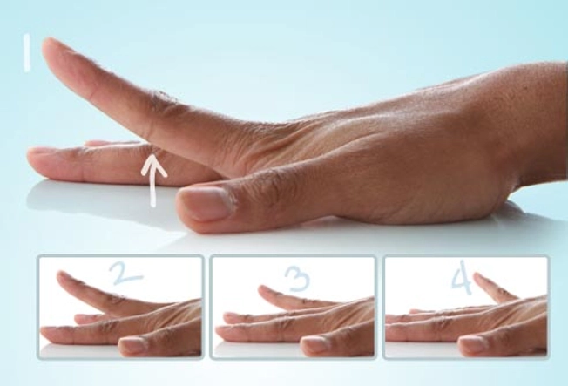

Thumb Extension
7/12
Strengthening the muscles of your thumbs can help you grab and lift heavy things like cans and bottles.
- Put your hand flat on a table. Wrap a rubber band around your hand at the base of your finger joints.
- Gently move your thumb away from your fingers as far as you can.
- Hold for 30 to 60 seconds and release.
- Repeat 10 to 15 times with both hands. You can do this exercise two to three times a week, but rest your hands for 48 hours in between sessions.
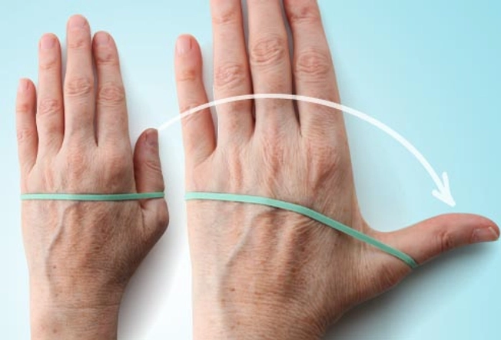

Thumb Flex
8/12
This exercise helps increase the range of motion in your thumbs.
- Start with your hand out in front of you, palm up.
- Extend your thumb away from your other fingers as far as you can. Then bend your thumb across your palm so it touches the base of your small finger.
- Hold for 30 to 60 seconds.
- Repeat at least four times with both thumbs.
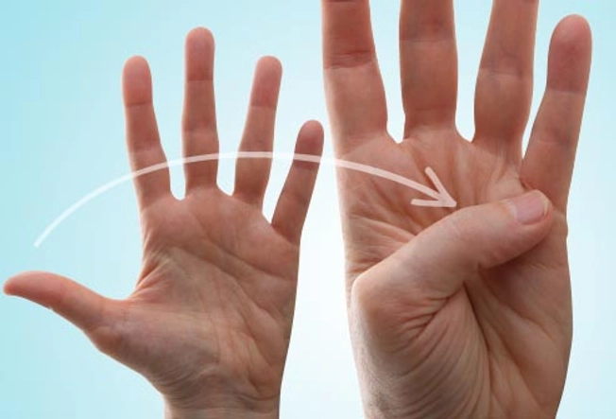

Thumb Touch
9/12
This exercise helps increase the range of motion in your thumbs, which helps with activities like picking up your toothbrush, fork and spoon, and pens when you write.
- Hold your hand out in front of you, with your wrist straight.
- Gently touch your thumb to each of your four fingertips, one at a time, making the shape of an "O."
- Hold each stretch for 30 to 60 seconds. Repeat at least four times on each hand.
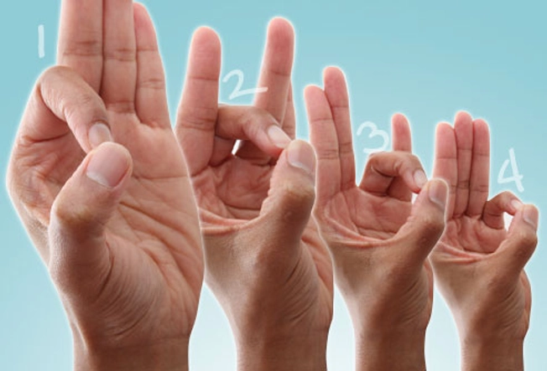

Thumb Stretches
10/12
Try these two stretches for your thumb joints:
- Hold your hand out, palm facing you. Gently bend the tip of your thumb down toward the base of your index finger. Hold for 30 to 60 seconds. Release and repeat four times.
- Hold your hand out, palm facing you. Gently stretch your thumb across your palm using just your lower thumb joint. Hold for 30 to 60 seconds. Release and repeat four times.
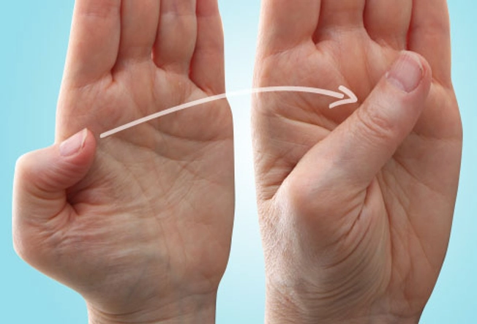

An Exercise Tip
11/12
If your hands and fingers feel painful and stiff, try warming them up before you exercise. This can make it easier to move and stretch. Use a heating pad or soak them in warm water for about five to 10 minutes. Or, for a deeper warmth, rub some oil on your hands, put on a pair of rubber gloves, and then soak them in warm water for a few minutes.

Play With Clay
12/12
Playing with putty or clay is a great way to increase the range of motion in your fingers and strengthen your hands at the same time. And it won't even feel like exercise. Just follow the kids' lead -- squish the clay into a ball, roll it into long "snakes" with your palms, or use your fingertips to pinch spikes on a dinosaur.

